# District Website – Sign in – Sign out

From web browser – find Sign in – upper right.

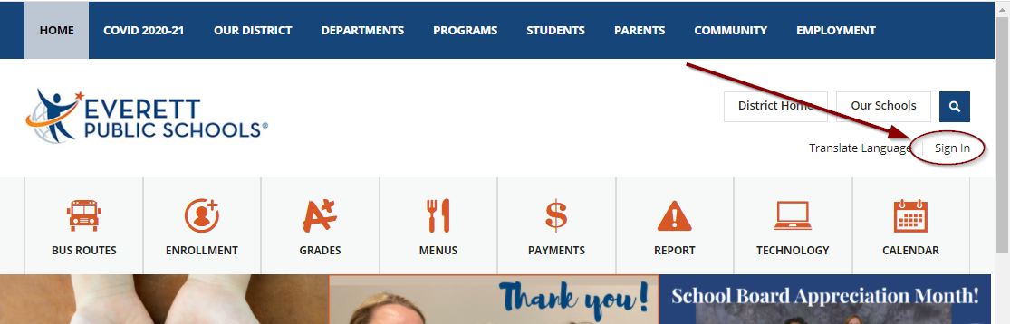

Type in your ID for User Name and your computer password in the Password field

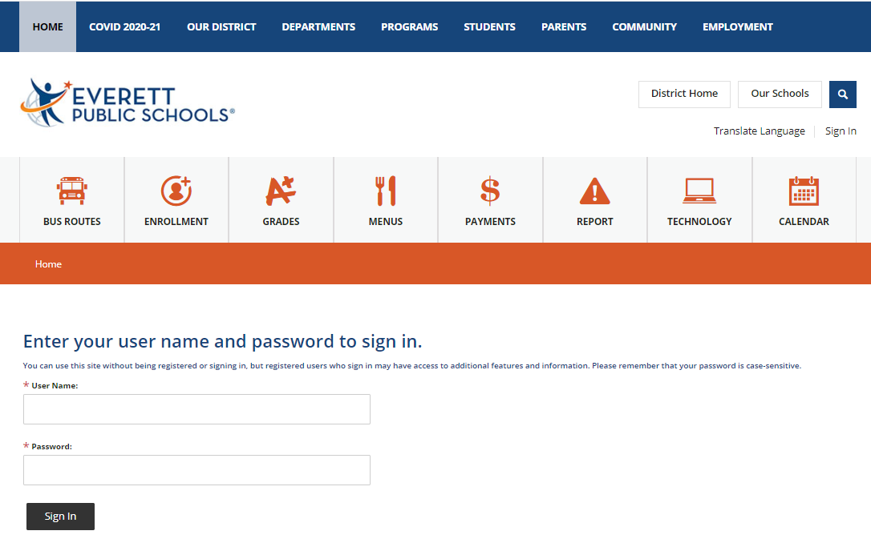

Once signed in you will see User Options in upper right. From there you can change account settings or Sign Out.

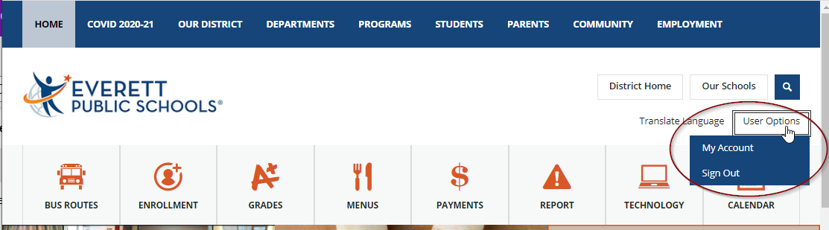

From mobile view – find Menu with three lines in upper left and select User Options

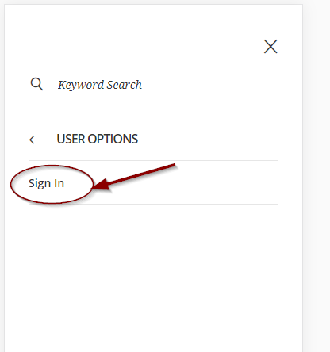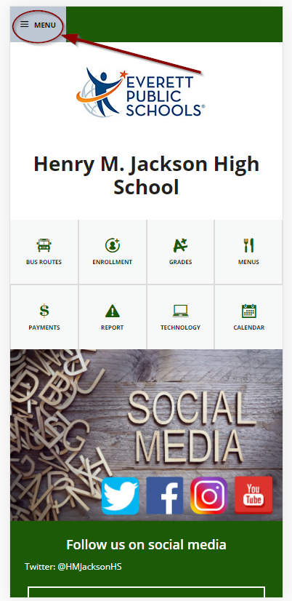

Type in your ID for User Name and your computer password in the Password field.

When ready to sign out – select User Options again

